Software Requirements and Design Document

For

Group 4

Version 1.0

Authors:
Parker Lee
Jordan Rydzinski
Ingrid Perez-Valezquez
Aidan Mahoney
Bao Tran

Overview (5 points)
Give a general overview of the system in 1-2 paragraphs (similar to the one in the project proposal).

Webkins is an interactive zoo-themed web application dedicated for animal lovers. Built primarily with javaScript, CSS, and HTML, the platform aims to transform live animal feeds and images into an educational game experience. Inspired by traditional zoo cam websites, Webkins differs by incorporating Geoguessr-style challenges, species identification games, and interative maps. Players will have opportunities to guess an animal’s geographical origin by placing a pin on a world map, compete in timed or multiplayer modes, with leaderboards and daily challenges, unlocking fun facts and educational blurbs that deepen their understanding.

In addition to its geoguessr-style game mode, Webkins will also feature a species guessing mode that gradually reveals blurred animal images, rewarding quick and accurate guesses. As well as a random zoo can function allowing players to explore live feeds from around the world, encouraging awareness of different zoos. While the web application involves challenges such as third-party API integration, data management, and deployment, Webkins aims to be an alternative of the traditional zoo live feed websites.

Functional Requirements (10 points)
List the functional requirements in sentences identified by numbers and for each requirement state if it is of high, medium, or low priority. Each functional requirement is something that the system shall do. Include all the details required such that there can be no misinterpretations of the requirements when read. Be very specific about what the system needs to do (not how, just what). You may provide a brief design rationale for any requirement which you feel requires explanation for how and/or why the requirement was derived.

Zooguessr
1. World map API integration, displaying interactive map for user to select locations (High)
2. Distance measure/Score computation (High)
- Alternate game mode implementation (Medium)
- Real-time live multiplayer mode, syncing of activity from two separate clients (Medium)
- Animal display/info (Low)
Speciesguessr (classification game)
- Image deblurring (High)
- Score computation (High)
- Alternate game mode implementation (Medium)
- Animal display/info (Low)
Random live cam viewer (High)
- Live cam scraper/database (High)
- Random selection button (Low)
Misc.
- Database integration (High)
- API integration (High)
- User Accounts/Authentication (Medium)
- Leaderboards (Medium)
- GDPR and CCPA compliance if needed (low)

3. Non-functional Requirements (10 points)
List the non-functional requirements of the system (any requirement referring to a property of the system, such as security, safety, software quality, performance, reliability, etc.) You may provide a brief rationale for any requirement which you feel requires explanation as to how and/or why the requirement was derived.
1. Dynamic frontend w/ React
2. Secure supabase integration for user accounts in accordance with proper user data laws.
3. Secure storage of API keys
4. All code must be maintained in a version control environment
5. Proper server security configuration such as firewall setup, ssh access, and graceful restart if a crash occurs.
6. Disclosure: Adding a disclaimer that we are only using the webkinz.tech domain for a class project to distinguish from the legitimate webkinz website.

4. Use Case Diagram (10 points)
This section presents the use case diagram and the textual descriptions of the use cases for the system under development. The use case diagram should contain all the use cases and relationships between them needed to describe the functionality to be developed. If you discover new use cases between two increments, update the diagram for your future increments.
Textual descriptions of use cases: For the first increment, the textual descriptions for the use cases are not required. However, the textual descriptions for all use cases discovered for your system are required for the second and third iterations.
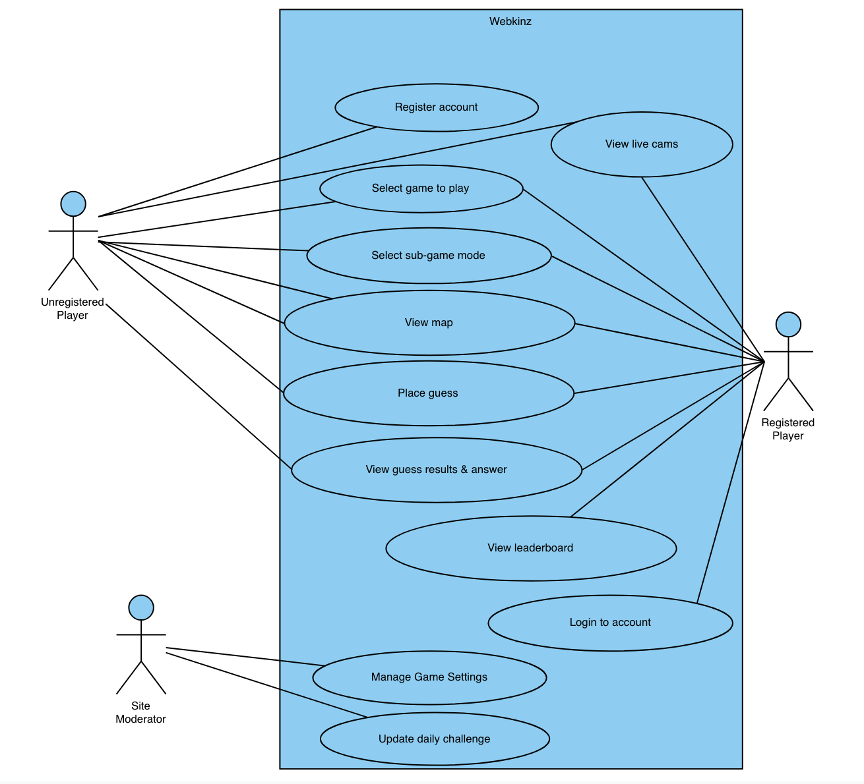

5. Class Diagram and/or Sequence Diagrams (15 points)
This section presents a high-level overview of the anticipated system architecture using a class diagram and/or sequence diagrams.

If the main paradigm used in your project is Object Oriented (i.e., you have classes or something that acts similar to classes in your system), then draw the Class Diagram of the entire system and Sequence Diagrams for the three (3) most important use cases in your system.

If the main paradigm in your system is not Object Oriented (i.e., you do not have classes or anything similar to classes in your system) then only draw Sequence Diagrams, but for all the use cases of your system. In this case, we will use a modified version of Sequence Diagrams, where instead of objects, the lifelines will represent the functions in the system involved in the action sequence.

Class Diagrams show the fundamental objects/classes that must be modeled with the system to satisfy its requirements and the relationships between them. Each class rectangle on the diagram must also include the attributes and the methods of the class (they can be refined between increments). All the relationships between classes and their multiplicity must be shown on the class diagram.

A Sequence Diagram simply depicts interaction between objects (or functions - in our case - for non-OOP systems) in a sequential order, i.e. the order in which these interactions take place. Sequence diagrams describe how and in what order the objects in a system function.
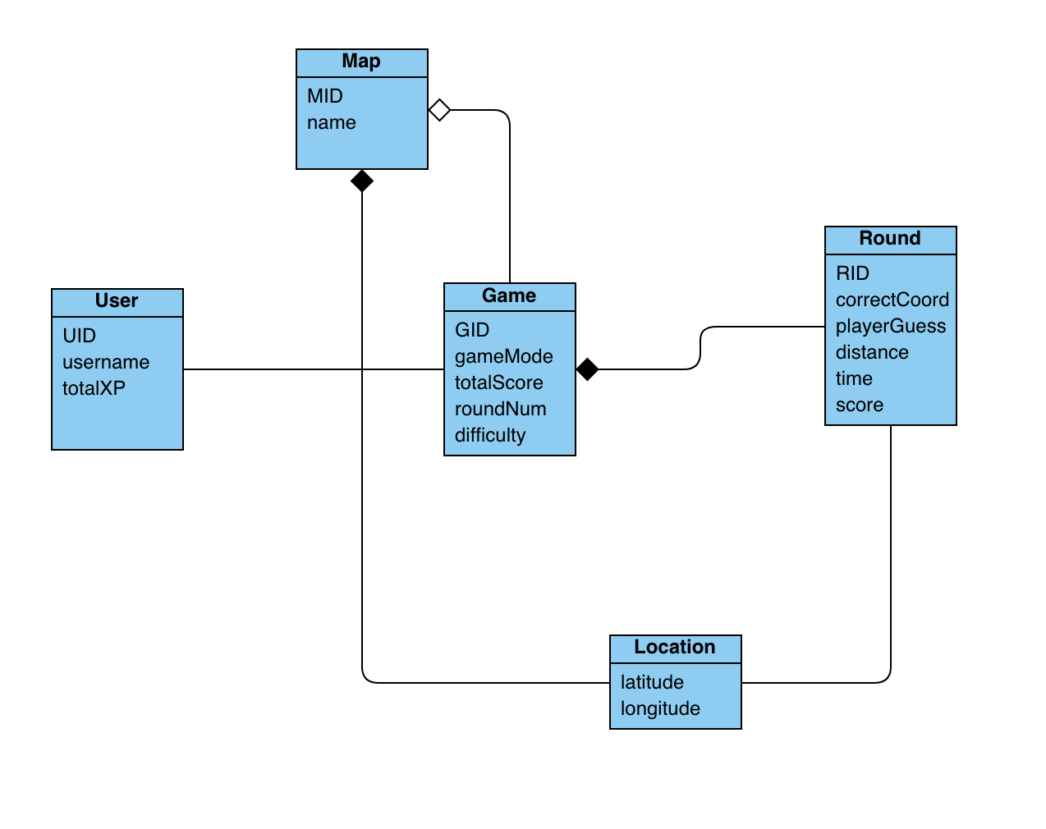

6. Operating Environment (5 points)
Describe the environment in which the software will operate, including the hardware platform, operating system and versions, and any other software components or applications with which it must peacefully coexist.
The current environment in which the software will operate is on a VM hosted by Digital Ocean. The server is an Ubuntu Server 24.04 LTS with 64x linux kernel. The hardware is 1 vCPU with 1GB Memory and 25 GB SSD. Nginx version 1.24.0 currently runs the web server by cloning the repository on a regular shell script. Certbot in a python virtual environment was added to ensure HTTPS. The repository is stored in /var/www/html with a virtual python environment established in the “home” folder directory to regularly update mapping.html.

7. Assumptions and Dependencies (5 points)
List any assumed factors (as opposed to known facts) that could affect the requirements stated in this document. These could include third-party or commercial components that you plan to use, issues around the development or operating environment, or constraints. The project could be affected if these assumptions are incorrect, are not shared, or change. Also identify any dependencies the project has on external factors, such as software components that you intend to reuse from another project.

- Troubles with third-party API access
- Compatibility of chosen libraries

